ANALYSIS OF INTERACTIONS IN A UNIVERSITY COURSE SUPPORTED BY BSCW

- Martínez¹, J.A.Marcos², I. Garrachón², Y. Dimitriadis³,
P. de la Fuente¹ and B. Rubia³

¹Department of Computer Science.
² Department of Communications, Signal Theory and Telematic Engineering
³ Department of Didactic and Educative Organisation
Universidad de Valladolid, Valladolid, Spain.
amartine@infor.uva.es

Abstract
After a period in which collaborative learning systems development has focused mainly in design issues, it is now time to concentrate on the evaluation of these systems. This evaluation is based on the constructivist principles of context and process awareness, and considers interactions between the learner and the environment as the unit of analysis. This paper presents a project in which a university course of Computer Architecture has been used as a particular case for the study of the evaluation process in CSCL environments. The project has been supported by BSCW and other telematic tools such as a debate organiser and electronic mail. It is a work in progress aiming at the integration of ethnographic data with automatic processing of the system event logs using social network analysis techniques.

1 Introduction

CSCL (Computer Supported Collaborative Learning) can be seen as the application of new pedagogical approaches based on constructivism and collaborative learning supported by the use of computer networks [10]. CSCL includes pure distance learning environments, in which the participants can communicate only through the computer; presential settings, where a group of students use the system in a classroom, with the presence of their partners; and finally, semi-presential environments, in which students are sometimes in the same classroom in ordinary lab sessions, but they also access the system remotely. Presentiality in these environments, whether it is total or partial has important consequences: first, the use of these systems is closely related to the daily processes of work in the classroom, and second, collaboration is performed in front of and through the computer [5].

The study of the interactions that take place in CSCL environments is receiving an increasing attention. There are at least two perspectives that justify this interest. The first one focus on the evaluation of the learning processes. The underlying theories of learning, whether they are based on cognitive or on sociocultural approaches [11], reinforce the value of the interactions of the learner with the physical and the social environment. Many authors see in CSCL systems a research opportunity for the study of these interactions [6].

Evaluating a CSCL system is a complex task, in which we have to consider many factors, such as usability, distributed computing, learning outcomes, the classroom context, etc. For this reason, many authors propose a multi-faced evaluation method, integrating quantitative and qualitative views [14]. A promising approach for the quantitative measurements is Social Network Analysis (SNA) [19], [22], oriented to the study of the features of the relationships established in social groups. It has been successfully applied in the CSCL domain [15].

The second perspective, more oriented towards system development, aims at the provision of support of the collaboration of the group, which has been recently denominated collaboration management [9]. The support functions range from the simple presentation of the state of the collaboration to the group to several forms of coaching.

The study of collaborative interactions, whether it is for evaluation purposes or for providing support has been dominated by an “analysis of dialog” perspective [17]. A recent approach, action based collaboration analysis [13], considers the actions performed by the users over shared workspaces as the base of the analysis, with very encouraging results.

Our group EMIC (Education, Media, Computer and Culture) has developed a framework for the development of CSCL constructivist environments called DELFOS (“A Description of a Tele-Educational Layer- Framework Oriented to Situations”) [16]. It proposes a methodology for the development of applications based on the participatory analysis approach [4]. We are currently working in the formalisation of evaluation aspects in DELFOS [12]. The study of collaborative interactions is a fundamental element for the evaluation of the learning and teaching processes, and for the provision of support by the system to its users.

With this research perspective, we set out a project in Computer Architecture studies using a project-based method with case studies that allow students to go through the principal tasks of design and evaluation of computer systems. It has been supported by the use of BSCW (Basic Support for Co-operative Work) [3] for the sharing of information resources and asynchronous debates, besides other tools such as a debate organiser and electronic mail.

Experimental work has taken place in two phases during the fall semesters (September to February) of the academic years 1999-2000 and 2000-2001. A complete description of the project and the results of the first year experiment are beyond the scope of this paper. They can be found in [7] and [8]. We will focus on this paper on the description of the evaluation procedure that has been designed for the analysis of interactions.

The rest of the paper is structured as follows. Next section presents a brief introduction to the educational project and to the experimental work we have carried out. Then, we present the issues related to the design of the automatic processing of BSCW event data using SNA techniques. The article finishes with the discussion of the provisional results and the research perspectives opened by this initial experience.

2. Description of the project

This section presents the background and objectives of educational project, its organisation, and the telematic support provided for its support.

2.2.1 The Computer Architecture educational project

Following the principles of the educational model of DELFOS [16] as well as the directives of the IEEE/ACM Computing Curricula [20], the project aims to provide contextualised, integrated and meaningful knowledge. The students face a project whose objective is the design and evaluation of computer systems oriented to different market sectors (i.e. producers of computer equipment, consulting firms, and clients). In order to have different perspectives of the problem, 5 distinct case studies were defined, covering different market sectors with different system requirements, such as a weather prediction institutes (supercomputing), airline ticket reservation companies (on-line transaction processing), etc. This way, in each class of a maximum of 40 students, at most 4 groups of 2 students each dealt with one out of the 5 case studies independently. The students assume the roles of a consulting firm and a computer manufacturer, and the teacher assumes the role of the client, and of the director of the producer companies.

The project is divided into three subprojects (situations, in DELFOS terminology) that study a specific issue of the whole problem. Each subproject presents two milestones: in the intermediate one basic decisions are made, collected though questionnaires and used in a synchronous debate. In the final milestone, besides the questionnaire and the debate, each group has to submit a formal technical report to the client. At the end of the whole project a technical report is collaboratively produced among all groups that deal with the same case study.

Co-operative learning has been carried out through the cited synchronous guided discussions in the revisions of the sub-projects, asynchronous document sharing and discussions through BSCW, as well as collaborative edition of the final project report. This design was supported by the following telematic tools:

- BSCW (Basic Support for Co-operative Work): it has been used for asynchronous document sharing, threaded discussion and as a workspace for the rest of the tools.
- Synchronous debate manager: its role is the support for the synchronous debates that take place in the project milestones (reviews). It permits the definition of a questionnaire by the teacher with close and open questions, the presentation to the students, and the collection of the responses presented in a table, pointing out possible conflicts (alarms). These alarms are used to introduce discussions in the debates.
- Electronic mail: used for communication purposes in which senders and recipients assume the roles of the project.
- Other tools: simulators and other tools related to the computer architecture domain were used by the students. We also considered the use of SunForum, a tool for the synchronous application sharing, but the latest version of 1999 was found to be rather unstable for classroom use.

2.2 Experimental work

Experimental study has been carried out in two phases, i.e. the fall semesters of academic years 1999-2000 and 2000-2001. As stated above, our approach to evaluation is based on the principles of qualitative evaluation, trying to integrate the potential benefits of the automatic processing of event data provided by the technological support.

The evaluation is the base for the analysis of the educational project, besides being a tool for the assessment of the teaching/learning process. Then, monitorization is essential to provide professor feedback, support student work and serve as a means for the reflection of the students about their own processes of construction of knowledge. In our case, the following data were used:

- Technical reports and regular student questionnaires evaluating the educational project, that were deposited in the BSCW shared workspace.
- Systematic ethnographic observations collected in the diary of an external observer, as well as voice transcriptions of the activities of a selected set of student groups.
- Grades and observations by the professor
- Computer logs, gathered from BSCW

These results in a large amount of data heterogeneous in form and nature. For the general organisation and processing of the data, NUD*IST [18], a well known qualitative data analysis software package was used. The quantitative analysis of events is done in the SNA based module, which provides measurements of the interaction patterns detected in the system. It shows analytically and graphically some features difficult to detect by human-based analysis of the data. The two tools will complement each other by the use of critical incidents [14], which are special features detected in a system. When one critical incident regarding collaboration is detected by one of the modules, the other will help to study it under other perspective which will help to enrich the knowledge about these special issues.
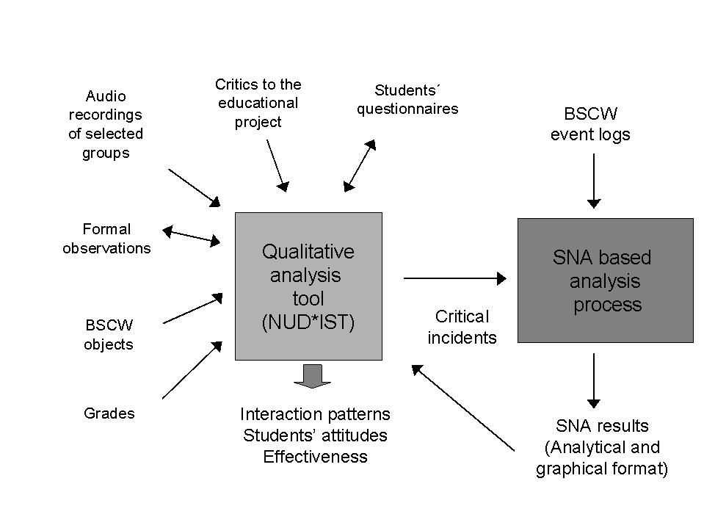
Figure 1. Schema of the evaluation procedure applied to the Computer Architecture course

Figure 1 shows the general schema of the evaluation. The bi-directional arrows show how the design of some sources (questionnaires, formal observations) was affected by on-going analysis performed during the course. The figure also presents as results those features we wanted to explore. In the experiment we describe here, we were specially interested in detecting issues concerning collaboration, such as interaction patterns and student attitudes towards collaboration.

3 BSCW-interactions analysis based on SNA methods

The SNA-based analysis tool is part of the general evaluation process presented above. Its main input is the data reflecting the actions performed by the users over the BSCW workspace. Therefore, one of the first issues we had to face was the study of the most suitable source of event data. Other issue was the selection of the most appropriate SNA measurements for our environment. This section explains the aspects related to the design and implementation of the module.

3.1 Collection of event data and configuration of the measurements

BSCW provides two possibilities for the collection of events: the daily workspace activity report, and the event log. The activity report is a function provided by BSCW for the support of group awareness, whereas the event log is mainly a debugging resource. Although none of them was initially conceived for group interaction analysis, we wanted to explore their possibilities as sources of event data.

The daily workspace activity report is a BSCW facility that notifies the users about the changes that affect the system. This report is sent by e-mail every day in either HTML or text format. It is organised by objects and it can be read and easily understood by a human reader. However, not all types of events, neither the repetitive events over the same object are represented. Only the last action is registered and communicated.

The event log in BSCW is composed by the set of events performed on the environment during a period of time, so that every action has its corresponding entry in the file. The events are stored time-stamped. As mentioned above, this file is produced mainly for debugging purposes, and therefore its structure is not clear neither it is well documented. The study of the fields of the entries in the event log was performed by a systematic process in which all possible types of events were simulated, and its entry in the event log was analysed to infer its meaning. This analysis confirmed that the event log could provide enough information for our purposes, although it had to be filtered in order to avoid redundancies and not needed entries.

In order to promote interoperability, a second step consisted in the translation of the event log to XML format [21]. We have defined a DTD (Document Type Definition), that describes the fields of each event that are meaningful for our purposes. Special decisions have been taken for improving efficiency in the treatment of the XML file.

3.2 SNA methods for the study of BSCW interactions

The most common network in SNA is the 1-mode network in which all the actors belong to the same set (i.e. the study of the messages sent during a period within group). In our scenario, most of the interactions to study do not belong to this type, as they are actions established over the shared workspace. For this situations, SNA defines 2-mode networks in which a group of subjects is related to a set of events. Techniques for 2-mode networks are not so much developed as for the 1-mode ones. Correspondence analysis [22] is one of the most used techniques. In this first experience, one of our objectives was to test the validity of these measurement. Instead of developing our own software, we are using an existing program, UCINET [2], a tool that implements correspondence analysis. The experience of applying and validating this technique in our scenario may lead eventually to define and develop new tools implementing other measurements, such as those defined in [1].

Taking into account the activity observed in BSCW during the two years, and considering the set of techniques provided by UCINET, we have defined the following networks and measurements:

- The participation of the students in BSCW asynchronous discussions is represented by a 1-mode network, to which centrality and betweeneness measures will be applied for the study of the participation in the discussions.
- 2-mode networks will be used to represent the events performed by the participants over a singular object (i.e.: the events performed by the class over the folder “discussions”); and to represent the interrelations between the users and a set of objects given a particular event (i.e.: users that have performed modifications to already existing objects).

The evaluation schema presented in the previous section demands a flexible tool, in which the researcher or the teacher can select the actual measurements, according to the issues observed in the qualitative analysis of data. This networks are configurable, so that the teacher or researcher will be able to define the actual set of actors that will conform the network, the event / object to study, etc.

4 Discussion

We have presented our initial approach for the evaluation of the interactions in a CSCL environment supported by BSCW and other telemetric tools. We have focused in the integration of ethnographic data with quantitative data automatically collected by BSCW, with the use of SNA, a set of techniques specially developed for the study of relational data.

We have defined the overall structure of the evaluation process, and from this approximation to the use of BSCW event logs, we have showed the limits of BSCW regarding the support of collaboration analysis. We can conclude from this point that BSCW (as well as any other CSCL system) should provide specific functionality for the storage and retrieval of actions performed on the workspace. This module should be open and configurable, well documented, and based on standard languages. Data should reflect semantic information, so that it can be automatically analysed. XML, which has been used in this approach, provides for all this requirements.

We think SNA techniques present good opportunities for the analysis of big amounts of relational data. However, there is no previous experience in its application to the analysis of shared workspaces. The results obtained must be interpreted carefully in order to validate the currently proposed techniques.

As stated in the introductory section of this paper, the analysis of interactions is also the basis for the definition of supporting functions provided for the management of collaboration. A further objective of our work will be the refinement of the system we have used, in order to enrich such functions. In this sense, we miss the provision by BSCW of an open programming interface for the extension of the basic functionality of the system.

Finally, the evaluation and the study of the interactions must take into account two features of this environment: the asynchronous and the semi-presential style of the interactions that take place in the environment.

5 Acknowledgements

The authors would like to thank for their contributions to this project to Eduardo Gómez, and to the members of the interdisciplinary group EMIC (César Osuna, José Lino Barrio, Teresa Blasco, Raquel Díaz, Rocío Anguita, and Ana Alario). We want to thank also the collaboration of the students of fourth year of Telecommunications Engineering. The research presented in this paper has been partially supported by the project VA/18 of the Junta de Castilla y León; the CICYT project TIC2000-1054 and the UE Leonardo da Vinci project EL/98/1/68108/PI/I.1.1.E/FPC.

References

[1] Borgatti, S. and Everett, M. (1997). Network analysis of 2-mode data. Social Networks, (19):243-269.
[2] Borgatti, S., Everett, M., and Freeman, L., editors (1999). UCINET 5.0 Version 1.00. Analytic Technologies, Natick.
[3] BSCW (2000). Basic Support for Cooperative Work. http://bscw.gmd.de.
[4] Chin, G., Rosson, M., and Carroll, J. (1997). Participatory analysis: Shared development of requirements from scenarios. In Proceedings of Human factors in computing systems, ACM CHI'97, Atlanta, USA, pages 162-197.
[5] Crook, C. (1994). Computers and the collaborative experience of learning. Routeledge, London.
[6] Dillenbourg, P. (1999). Introduction; What do you mean by “Collaborative Learning”? In Dillenbourg, P., editor, Collaborative Learning. Cognitive and Computational Approaches, pages 1-19. Elsevier Science Ltd., Oxford, U.K.
[7] Dimitriadis, Y., Martínez, A., Rubia, B., and Gallego, M. (2001). Cooperative learning in computer architecture: an educational project and its telematic support. In Proceedings of the Conference of Frontiers in Education, FIE 2001, Reno, Nevada, oct 10-13, 2001. To appear.
[8] Gallego, M., Díaz, R., and Dimitriadis, Y. (2000). Learning in collaboration in a project setting with telematic support in a real context (in Spanish). In VIII Congreso de Innovación Educativa en las Enseñanzas Técnicas and First Int. Congress in Quality and in Technology Education Innovation, San Sebastián, Spain.
[9] Jermann, P., Soller, A., and Muehlenbrock, M. (2001). From mirroring to guiding: a review of the state of the art technology for supporting collaborative learning. In Proceedings of European Computer Supported Collaborative Learning Conference, 2001, Maastricht, The Netherlands.
[10] Koschmann, T. (1996). Paradigms shift and instructional technology. In Koschmann, T., editor, CSCL:Theory and Practice of an Emerging Paradigm, pages 1-23.Lawrence Erlbaum, Mahwah, N.J.
[11] Littleton, K. and Light, P., editors (1999). Learning with Computers: Analysing productive interaction. Routeledge, London, U.K.
[12] Martínez, A., Osuna, C., Becerril, A., Dimitriadis, Y., de la Fuente, P., Barrio, L., and Blasco, T. (2000). Modeling interactions with a conceptual framework. In Analysis and Design of Educational Interactions. Workshop Notes, ECAI 2000, Berlin, pages 1-9.
[13] Mercer, N. and Wegerif, R. (1999). Is `exploratory talk' productive talk? In [Littleton and Light, 1999], pages 79-101.
[14] Muehlenbrock, M. and Hoppe, U. (1999). Computer supported interaction analysis of group problem solving. In Proceedings of Computer Supported Collaborative Learning, 1999, Stanford, Palo Alto, California. Available at http://sll.stanford.edu/CSCL99/papers/.
[15] Neale, D. and Carroll, J. (1999). Multi-faceted evaluation of complex, distributed activities. In Proceedings of Computer Supported Collaborative Learning, 1999, Stanford, Palo Alto, California, pages 425-433. Available at http://sll.stanford.edu/ CSCL99/papers/.
[16] Nurmela, K., Lehtinen, E., and Palonen, T. (1999). Evaluating CSCL log files by Social Network Analysis. In Proceedings of Computer Supported Collaborative Learning, 1999 Stanford, Palo Alto, California, pages 434-442. Available at http://sll.stanford.edu/CSCL99/papers/.
[17] Osuna, C. and Dimitriadis, Y. (1999). A framework for the development of educational collaborative applications based on social constructivism. In Proceedings of CYTED RITOS international Workshop on GroupWare, CRIWG '99, Cancún, Quintana Roo, México, pages 71-80. IEEE Computer Society Press.
[18] Pilkington, R., McKendree, J., Pain, H., and Brna, P., editors (1999). Analysing Educational Dialogue Interaction: Towards Models that Support Learning. Workshop 3, 9th International Conference on Artificial Intelligence in Education, AI-ED 99, Le-Mans, France.
[19] QSR (1997). QSR,NUD*IST. Software for qualitative data analysis. Thousand Oaks, CA, USA.
[20] Scott, J. (2000). Social Network Analysis. A Handbook. SAGE Publications, London, U.K., second edition.
[21] Turner, A. (1991). A summary of the ACM/IEEE-CS joint curriculum task force report: Computing curricula 1991. Communications of the ACM, 34.
[23] W3C (2000). Extensible mark-up language (XML). http://www.w3.org/XML/.
[24] Wasserman, S. and Faust, K. (1994). Social Network Analysis: Methods and Applications. Cambridge University Press, Cambridge, U.K.

